# Working title for thesis

The impact of climate changes on population genetic structure and dispersal potential of desert arthropods.

# Statement of Research (topic/problem)

Documenting genetic diversity of Antarctic invertebrates has been constrained by development of the sequencing technologies and by logistical and seasonal parameters involved in sample collection. As such, current genetic understanding of springtails and mites within the Ross Sea Region is limited to few specific studies (4 references here). With recent and continuously rapid advancements in sequencing technologies, it is becoming more affordable to process a larger number of specimens which drastically enhances our database and overall understanding of the role these soil invertebrates play in the ecosystem and how they may be impacted by changes in their environment.

This thesis will investigate the diversity of springtails (and mites) from terrestrial Antarctica (cold desert; polar), Namibia in South Africa (hot desert), Svalbard in the Arctic (polar), as well as New Zealand (local). More specifically, this thesis will assess (i) activity patterns and genetic diversity (COI) of *Gomphiocephalus hodgsoni* (Collembola) in Miers Valley relative to environmental measurements, (ii) activity patterns of Antarctic mites in several Dry Valleys relative to environmental measurements, (iii) genetic and species diversity of soil invertebrates in the Namib desert, (iv) genetic diversity of Arctic springtails, and (v) genetic diversity of New Zealand springtails as a temperate comparison to put these studies into a truly global perspective.

The overarching goal of this thesis is to better understand current genetic diversity among soil invertebrates (namely springtails) for the early detection of any changes in this diversity in response to changes in global climate.

Pete Convey

* Work at BAS in Cambridge on live samples they collected
* Field season with BAS in Signy or Rothera
* Svalbard (Natural Environmental Research Council NERC) station at Ny Alesund.
  + OR, University Centre in Svalbard (UNIS)
* Apply for money from Transantarctic association or Antarctic Science Bursary
* Get him to send me Peninsula springtails after SCP test (i.e. direct link with physiology and genetics)

# Introduction and Review of Literature

Springtails are the largest, year-round organisms to inhabit terrestrial Antarctica. They are important for ecosystem function as they feed on microscopic algae and fungi, contributing to nutrient cycling. Their fate in our changing climate will be important to monitor as it may be relevant for other soil arthropods globally, and will give a direct measure of the impact of changing environmental conditions on biology, rather than inferences based solely on measurements of those physical parameters.

Context and conceptual framework that my work will fit into.

Poster abstract:

Springtail habitat in Antarctica is extremely fragmented which has led to isolated and genetically distinct populations for several taxa. To assess how projected temperature increases will influence dispersal patterns and gene flow among populations, we will focus on the activity of Gomphiocephalus hodgsoni (Collembola). Pitfall traps (x20), aerial nets (x10) and stream drift nets (x6) will be deployed in Miers Valley of southern Victoria Land, Antarctica to sample G. hodgsoni at regular intervals (e.g. hourly) over two-weeks in January 2016. The aim of the study is to provide a fine-scale assessment of springtail activity relative to environmental conditions at the time of their capture. The number of individuals collected for each method will be used as a surrogate for their ability to disperse via land, wind or water during their most active time of year (i.e. mid summer). Individuals will also be sequenced for variation in their mitochondrial COI gene, to detect any patterns in activity for specific genetic variants (COI haplotypes). With projected increased air temperatures and resulting glacial melt, hydrological connectivity is likely to increase within the Antarctic landscape, creating more opportunities for springtail dispersal. Greater connectivity among springtail populations would increase gene flow, altering their overall genetic diversity. We will use these data to suggest the likely biological impact of predicted climate changes in Antarctica.

## First Antarctic Expeditions and species descriptions

The first collection of springtails in the Ross Sea Region occurred during the 1901-1904 British National Antarctic Expedition (a.k.a. the Discovery Expedition). Six individuals were collected with moss from somewhere in the Dry Valley region. The species was later named *Gomphiocephalus hodgsoni* (family Poduridae) after the expedition’s marine biologist Thomas Vere Hodgson (Carpenter, 1908).

The second collections of *G. hodgsoni* were made during the 1910-1913 British Antarctic Expedition (a.k.a. the Terra Nova Expedition). While Scott’s main party were travelling to the South Pole, one of the additional expeditions involved a geological survey of the Mackay Glacier region. On November 30 1911, Taylor discovered *G. hodgsoni* floating on the surface of a small pool and then also found individuals under pebbles, realising that these springtails move around once they warm up (Carpenter, 1921). Taylor thought that the smaller individuals he found were a different species, although they were deemed juvenile G. hodgsoni, according to Nelson. He embalmed his collections in seccotine, which unfortunately affected fine morphological features, then stored them ethanol Morphological descriptions of these specimens were made later, providing greater detail and amendments to the original descriptions from in 1908 from the 6 fragmented specimens collected on the 1901-1904 expedition.

The idea that springtails have been associated with the Antarctic landscape since it was part of Gondwana (X MYA) is a common theme presented even in these early descriptive papers (Macnamara, 1919; Salmon, 1962a, 1962b).

## Early Work on Antarctic Springtails

In the 1960s Antarctic springtail ecological research covered habitat (Gressitt & Leech, 1961), further morphological descriptions of *G.hodgsoni* and new descriptions of other species (Salmon, 1962a, 1962b), soil habitats and lab temperature experiments on *G. hodgsoni* (Janetschek, 1963), *G. hodgsoni* body length and instars (Janetschek, 1967).

### Antarctic Climate and Landscape

Past glacial cycles, geographical barriers, species’ ranges (G. hodgsoni has the largest range – Janetschek 1967; Stevens and Hogg 2002), Environmental drivers and habitat

## Springtail Isolation and Evolution

Dispersal mechanisms, freeze avoidance strategies

### Genetic Diversity

Mutation rates, haplotype variation, mtgenome, transcriptome?

(other springtail species? Antarctica/elsewhere?)

## Springtail Physiology

Metabolic rate variation, SCP experiments, protein thermal tolerances?

## Gomphiocephalus hodgsoni

Life cycles, instar duration, gut contents

## Predicting effects of climate change on local biota

New founder populations?

^ this will be the full literature review, from which I will choose a shorter version for the proposal.

Gaps in the knowledge – intensive, fine-scale assessments of Antarctic springtail diversity.

# Research Questions and Hypotheses

This thesis aims to quantify the ability of springtails to disperse via land, water and wind vectors, ultimately to provide predictions on how their dispersal and overall genetic diversity may be influenced by changes in climate.

Hypotheses that will be tested:

1. The number of springtails transported downstream by glacial melt will be positively correlated to total discharge.
2. Springtails will have maximum dispersal capability (land and water) during periods of peak air temperatures.

Thesis with publication

Chapter I: Thesis introductory chapter

Chapter II: Literature review and review paper (Genetic diversity of the Antarctic springtail *Gomphiocephalus hodgsoni*: A review of current understanding)

Chapter III: Research chapter (all three trapping methods)

Chapter IV: Research chapter (get mites to work) (vertical migration) (collection method comparisons) (#/m2)

Chapter V: Research chapter (P Convey SCP🡪 COI)

Chapter VI: Research chapter (NZ springtails – collection methods, north vs south island)

Chapter VII: Thesis conclusion, pulling it all together

Appendices: Other opportunistic/pilot studies

# Materials and Methods

## Study Site

As part of the K020 event team in the 2015/2016 Antarctic field season, field work will be carried out in Miers Valley, the southern-most of the six dry valleys in southern Victoria Land (Figure X). At approximately 12 km long, Miers Valley contains a simple hydrological system consisting of two Glaciers (Miers and Adams) that each feed into Miers Lake which drains into McMurdo Sound (Figure X). Pitfall traps and wind nets have previously been set up in Miers Valley during the 2009/2010 season at approximately 860 m downstream from Miers Glacier (Figures X, X; Table X). Traps were cleared daily throughout December and January by either Ian Hogg, Nick Demetras or Eric Bottos. Once processed and analysed, these results will facilitate somewhat of a 6-year comparison between the genetics of *G. hodgsoni* from 2009/2010 and 2015/2016. To maximize the comparison potential, the study site will encompass roughly the same area as per the 2009/2010 season. Regular sampling (e.g. two-hourly) will be carried out during the two-week field season.

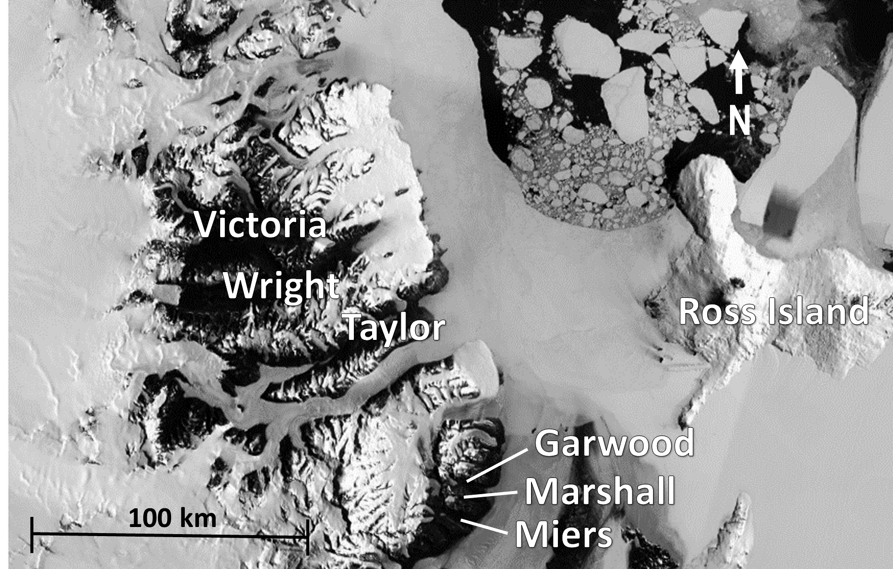

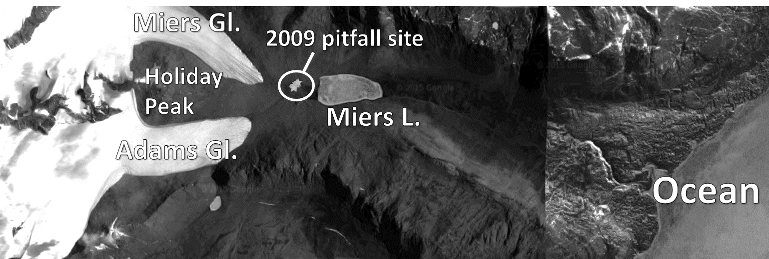

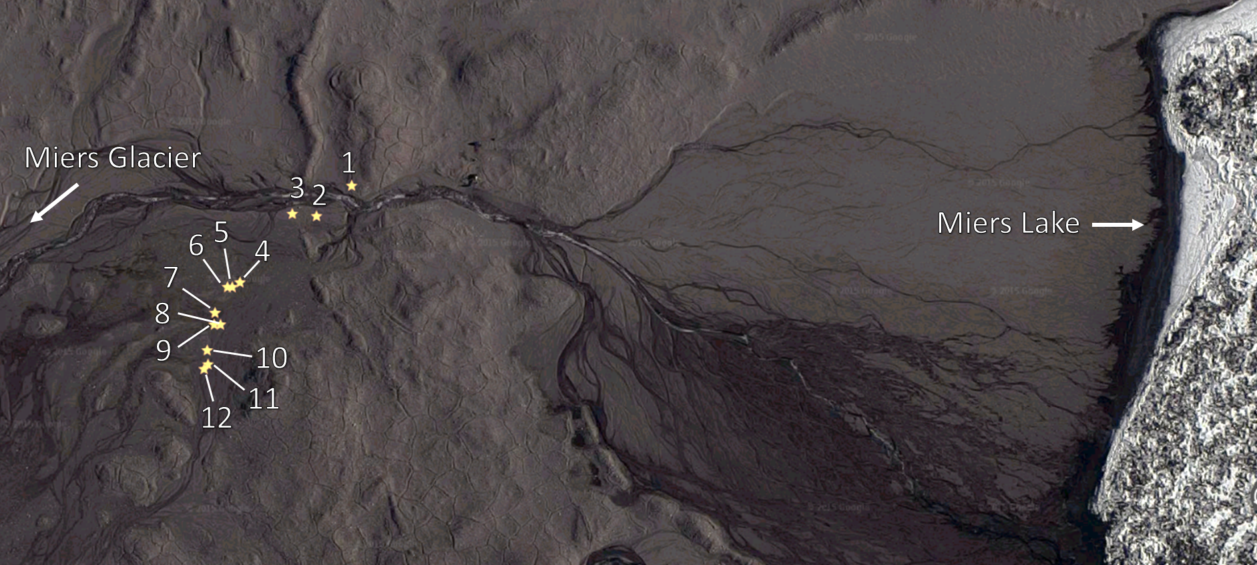

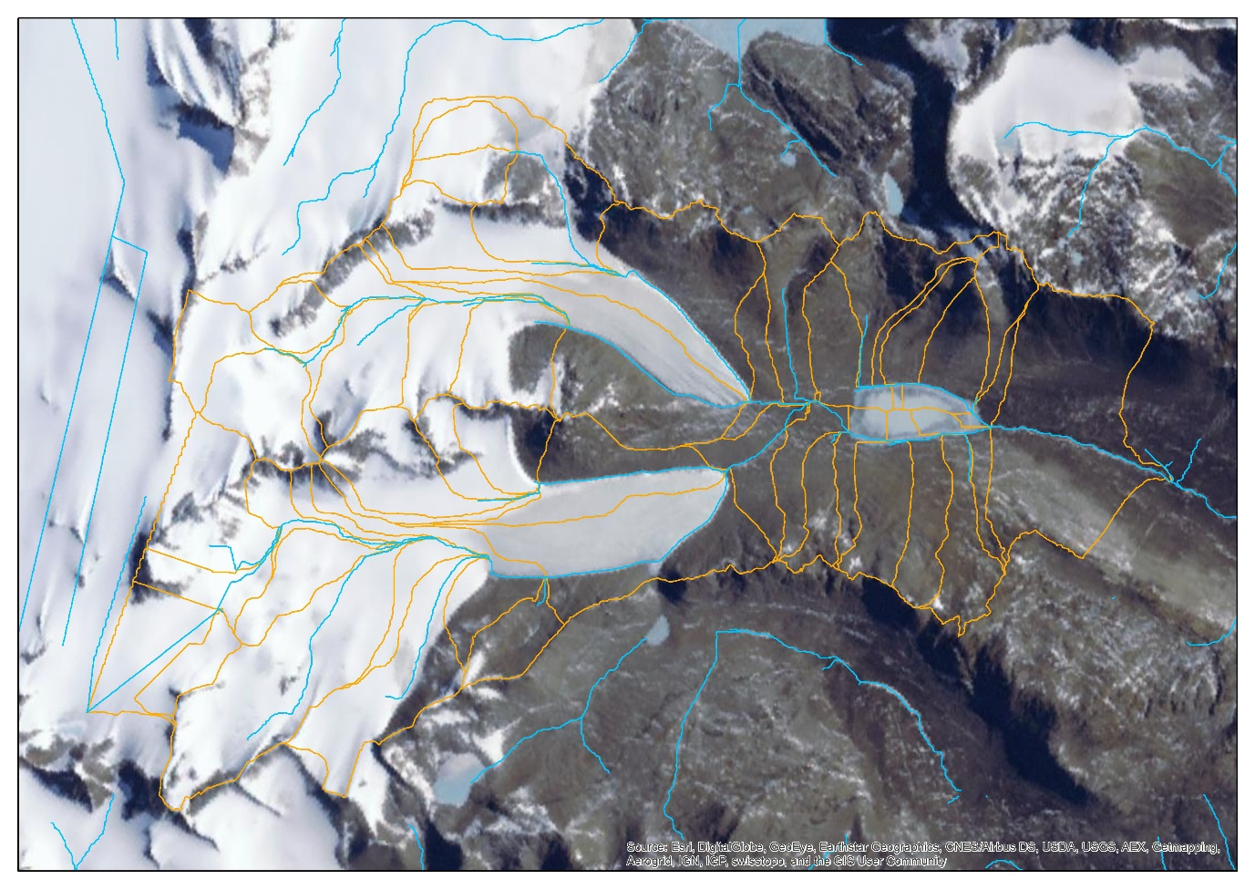

|  |  |  |
| --- | --- | --- |
| Pitfall trap | Latitude | Longitude |
| 1 | -78.096033 | 163.786217 |
| 2 | -78.096250 | 163.785000 |
| 3 | -78.096233 | 163.784183 |
| 4 | -78.096717 | 163.782383 |
| 5 | -78.096750 | 163.782117 |
| 6 | -78.096750 | 163.781967 |
| 7 | -78.096933 | 163.781533 |
| 8 | -78.097017 | 163.781717 |
| 9 | -78.097017 | 163.781500 |
| 10 | -78.097200 | 163.781267 |
| 11 | -78.097300 | 163.781283 |
| 12 | -78.097333 | 163.781167 |

## Pitfall Traps

Pitfall traps were first designed and deployed in the dry valley setting in 2000 (Stevens 2006): Arthropod activity at Capy Geology (Granite Harbour) assessed using 10 pitfall traps with glycol for 57 days in total – 24 Nov 2000 set up, open for 4 days with the 5th day blank, until 26 January 2001. 0900 and 2100 sampling. Wind velovity (15 cm above ground), lumens, temp (15 cm above ground; 1cm below ground; under a rock) RH (soil and air). 24 COI haplotypes. Greater springtail activity when temp and light increase, but no ‘response’ to wind speed. Mites (S. mollis) no pattern. Mites more active in general than springtails, and wider dispersed.

Nov 2006 at Cape bird (McGaughran et al. 2009). 10 traps checked at 0900 and 2100 for 4 consecutive dyas, then closed each 5th day. Plus iButtons (RH; 30 min intervls). (Beginning Dec to end Jan: 6 x 10day blocks). Significant relationships between pitfall activity and the microclimate conditions max temperature and temperature range.

Nov 2007 (McGaughran et al. 2011). 10 traps checked at 0900 and 2100 from 13 Nov (until 23) then 7-23 Jan. # springtails/day in January was not significantly different than for November. Plus iButtons (10 min intervals).

One vial PER pitfall trap.

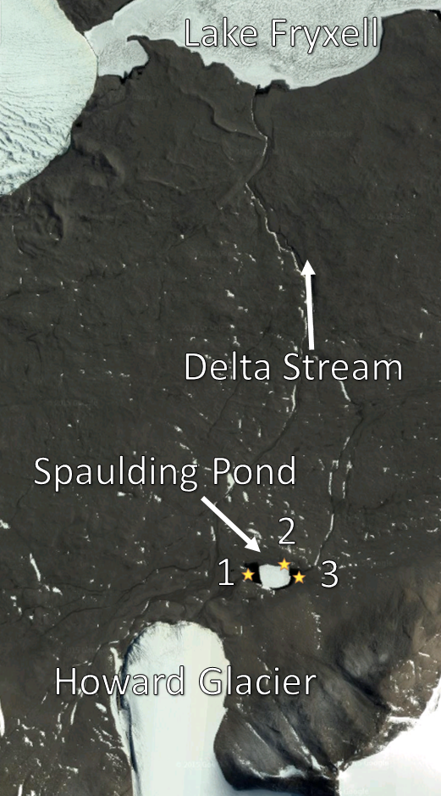

## Aerial Traps

Sampling for wind-dispersed organisms will be undertaken using specially designed and built windsocks previously used in the dry valley setting.

Early in Antarctic research it was thought that air currents are important for long-range dispersal and are the main vector for the introduction of insects to Antarctica and surrounding islands. Previous studies have assessed insect aerial dispersal in the Antarctic area through the use of aerial nets on ships, planes and on land (Gressitt, Leech, Leech, Sedlacek, & Wise, 1961; Gressitt, Leech, & O’brien, 1960; Yoshimoto, Gressitt, & Mitchell, 1962). However, Collembola were scarcely collected using these methods, with one Poduridae (67° - 68°44’) and one Tomoceridae (70°49’ - 85°31’) individual collected in early 1960 at two locations within the Antarctic Circle (Gressitt et al., 1960). Air net collections in more temperature areas similarly yielded extremely low collembolan counts, with one individual collected at each of also only two locations (45°46’; 21°50’ - 22°05’) in January 1962 (Yoshimoto et al., 1962). These early studies had a very widespread focus and the chance of wingless invertebrates being caught in the air above ocean would be low. For land-based assessments, air traps were set up at three main locations on Ross Island as well as at Marble Point. Traps were checked once or twice a week and approximately 12 km3 of air was screened. From all 100 or so nets, only one individual (Poduridae) was collected at Marble Point on 16 Dec 1959 and this extremely low success rate was put down to the prevailing southerly winds, although air circulation was poorly understood at that time (Gressitt et al., 1960).

More recently, air nets have been deployed in Miers Valley during the 2009/2010 season (data unpublished). A total of XX springtails (*G. hodgsoni*) were collected during the X week sampling period. This low collection number could be due to exact positioning of the nets with respect to the wind dynamics within Miers Valley (GPS locations?). Although collembolan air collections in the Antarctic environment have remained unsuccessful in the past, it will be important to include in the present study as it will enable a holistic analysis of dispersal across all three possible mechanisms: land, water and air.

McGaughran 2011 #4: assessed potential for wind dispersal near the ground surface and installed aerial traps on the 13 Nov 2007 which consisted of 5 circular plastic containers (put onto the ground) with sticky tape around the top to prevent stuff getting in any other way but via air. Traps contained water-glycol and stones held them in place. Traps surveyed daily. A total of 9 springtails were trapped across the whole sampling period, max 2 per day (mainly 10-19 Jan). Main conclusion: G. hodgsoni can survive short periods of aerial dispersal ~ 20 m.

Ten nets, which were specially designed will be used in the upcoming 2015/2016 season. Due to previous low springtail yields using this method, air nets will be left in place for the duration of the field season (approximately two weeks) and any individuals captured will be euthanised and preserved in 100% ethanol for subsequent genetic anlayses upon return to New Zealand.

Description of net apparatus:

Sketch with dimensions and distance from the ground.

In Velasco-Castrillon 2014:

“Microfaunal dispersal and occurrence

Information on dispersal of Antarctic invertebrates results

from casual observations from arthropod collections,

which have received comparatively more work in Ant-

arctica (see Convey et al. 2008, 2009). It is believed that

air currents are one potential mode of passive dispersal

(Miller and Heatwole 1995;Greensladeetal. 1999;Mu-

n ˜oz et al. 2004;Nkemet al. 2006; Hawes et al. 2007).

This method of transport may not be as successful for

arthropods (springtails, mites, dipterans) due to potential

desiccation (see Marshall and Pugh 1996). Other possible

dispersal mechanisms are birds (Stevens and Hogg 2002),

bubbles carried in water currents (Rounsevell and Horne

1986)oronfloating materials in melt-water streams

(Moore 2002; Sinclair and Stevens 2006).”

## Drift Nets

### Background

Drift nets have been used for well over 80 years to look at invertebrates being washed down streams and rivers (Needham, 1928), although taxa such as chironimids, EPT and diptera are often the focus (refs). In Antarctica, springtails are known to survive on the surface of both fresh and marine water for up to 10 days, referred to as rafting, and this is their most effective mechanism for dispersal (Hawes, 2011; McGaughran, Hogg, & Convey, 2011). To assess the number and haplotype diversity of *G. hodgsoni* that are transported via small glacier-fed streams, drift nets will be installed and regularly sampled. Supporting measurements such as stream width, depth profile and flow rate will be made for extrapolation of results to give number of springtails transported per discharge (m3s-1). This is relevant for future studies predicting the impacts of climate change on Antarctic terrestrial biota, as likely increases in hydrological connectivity could result in greater springtail dispersal and therefore a more connected gene pool.

Rafting:

Passive dispersal is an important mechanism for springtails in the ice-free environment (Hawes, 2011). The first descriptions of rafting in G. hodgsoni under natural conditions at Granite Harbour for 10 days in Jan 2009 (lab experiments: Hawes et al. 2008 C. antarcticus; fresh and salt water McGaughran et al.) and first record of mites rafting too (Stereotydeus) (Hawes, 2011). Moult exuviae and other detritus extends the chance of survival in the rafting situation and also allows them to move around a bit on the surface (Hawes, 2011). (Hawes, 2011) also found G. hodgsoni on the edge of the sea, although surrounded by ice it shows the potential for marine dispersal. Rafting springtails are exposed to UV-R. Springtails randomly end up in a rafting situation, but it happens often enough that it is an important phenomenon for springtail ecology (Hawes, 2011).

### Previous work

Research:

Tim Dawes from Otago (and Mark Stevens) – Collembola and survival on streams via rafting.

Has anyone looked at stream flow + invertebrates? And Collembola specifically?

Marshall.

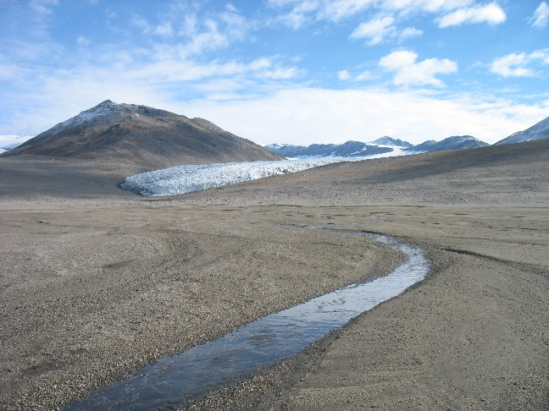

Miers Stream and Glacier: <http://huey.colorado.edu/77DegreesSouth/glaciers3.html>

Stream Team: https://b506m.wordpress.com/

“As we have mentioned before, these gauges consist of a big wooden box full of gadgets that essentially record the resistance it takes to pump a bubble of nitrogen out, which is proportional to the height of the water column above. However, the trick is to know the relationship between this value and the amount of water that is actually flowing in the stream at a given moment. To do this, we make manual discharge measurements.”

“Manual measurements are done either with a pygmy meter (an updated version above) or a portable flume (below). The pygmy meter is an elegant tool that requires you measure the depth and the speed of the water by counting the rotations of a wheel at the bottom of a staff along different parts of a transect. By knowing the amount of water passing through the resulting “little rectangles”, one can calculate the discharge for the entire stream. The flume on the other hand uses marks on the sides to measure how much water is passing through at a given moment. The portable flume can therefore be a much quicker method, but can only be used at low stream flows.”

https://psumcmdv.wordpress.com/2013/01/04/170/

The Stream Team has had a busy, fun-filled week. The hi-light so far was Friday’s trip to Miers Valley. We collected water samples and measured discharge on Adams Glacier Stream, Miers Glacer Stream, and Miers Outlet Stream. I also deployed several data loggers to measure specific conductance, temperature, and water height in Miers Outlet Stream, and Miers Glacer Stream.

While we were working at the Adams Glacier Stream gage, we noticed an abrupt change in discharge. This daily variation in solar intensity on glaciers results in daily flood events, which can clearly be seen on streamflow hydrographs. A hydrograph is a record of stream discharge over a period of time. check out the hydrograph at Green Creek to see what I’m talking about… http://www.mcmlter.org/queries/hydro_graph.jsp?begDate=10/01/2009&endDate=04/01/2010&hydroStation=GREEN

http://mcm.lternet.edu/content/lower-miers-stream-gage-measurements-1990-91&displaymodule=entity&entitytype=dataTable&entityindex=1

1990/1991 season in Miers Valley

Miers Valley LOWER stream (coastal) January 1991: Stream discharge ranged from 0 – 199 L/second with a mean discharge of 37 L/second

http://mcmlter.lternet.edu/queries/streams/streams_gauge_locations.jsp

STRM_GAGE_LOCS,adams_miers,Adams Stream,Adams Stream upstream of Miers Lake,-78.08999633789062,163.77000427246094,0.0,null,e-mail from Mike Gooseff Re: DOC results 7/18/2000

STRM_GAGE_LOCS,miersup_5,Miers Stream,Upper Miers Stream at sample site 5,-78.09722137451172,163.76666259765625,0.0,null,null

STRM_GAGE_LOCS,miersup_flume,Miers Stream,Upper Miers Stream at flume,-78.09722137451172,163.75,0.0,sample site 3; kiwi site 3500026,null

STRM_GAGE_LOCS,mierslow_1,Miers Stream,Lower Miers Stream at sample site 1,-78.12083435058594,164.1999969482422,0.0,null,null

STRM_GAGE_LOCS,miers,Miers Stream,Variable,0.0,0.0,0.0,Miers is sampled each season but the location varies - Lat and Long can be found in the Comments column of the field measurement table,null

STRM_GAGE_LOCS,mierslow_weir,Miers Stream,Lower Miers Stream at Weir,-78.10221862792969,163.89999389648438,0.0,kiwi site 3500025,null

### Research Goal

To quantify invertebrate dispersal/connectivity across Antarctic stream and terrestrial landscapes - Extrapolate number of springtails collected in drift nets to estimate total number of springtails floating down the Miers Valley stream, and also in other Antarctic systems, with particular focus on how the number of dispersing springtails might increase with climate changes.

This work will contribute to the “Interconnectivity Between Aquatic and Terrestrial Habitats” component whereby “We will determine the extent to which wind and water connect habitable MDV locations, both within and between valleys”. Hydrological connectivity between habitats is being investigated by GIS. Streams with high hydrological connectivity will have been identified and we propose to target these sites to investigate whether hydrological connectivity relates to biological connectivity.

### Installation and Collection Regime

Springtails will be captured in a series of mesh nylon driftnets installed across a transect of the stream that consists of Miers Glacier meltwater, travelling down Miers Valley to feed Miers Lake. The specific location for the driftnets to be installed will target a deep and narrow passage, upstream from where it becomes shallow and spreads out into a wider array of smaller tributaries. There will be a total of five drift nets installed, one being directly in the centre of the stream and two on either side. If warmer weather is encountered and the stream level rises, the outermost nets will become inundated. Likewise, when stream level subsides during cooler periods, some nets will not be in contact with the water. This will allow for the dataset to answer the question: Are haplotypes that wash down the stream during periods of high flow different to haplotypes that are washed down the stream during periods of low flow? If flow suddenly increases then springtails near the stream may be accidentally washed down amd it would be interesting to find out what haplotypes those individuals have.

More than one net should be used to get a fair representation of what is in/on the stream (Brittain & Eikeland, 1988; Matter & Hopwood, 1980).

### Design Brief

Thought will be given in the installation of driftnets so that springtails can only enter the net via water. This will involve nets being slightly raised off the ground surface, preventing walk-ins.

Make 6 drift nets. Features:

▪ Floats so always sampling surface

▪ Attached to bottom (with depth scale up the side)

▪ Material to filter springtails but not get clogged with particles

▪ Consideration for regular sampling – can pull the whole thing out of the water to remove the sample jar.

▪ Net and sample jar below the net entrance to ensure springtails are washed all the way into jar

▪ Something to deflect water at front? Water physics.

▪ 3 small, 3 medium, 2 large??

Dean can make the sampling jar attachment

Lee can make the material component

Workshop – Michael and Martin – can make the solid frame

http://www.hoskin.ca/catalog/index.php?main_page=product_info&cPath=1_57_363_369_374&products_id=1032&zenid=9eejv28233dfqlr1vjh5a78v76

These stationary nets, 39” in length with an 18" wide by a 12" tall frame

^ This idea for a frame that the net would fit into. That would reduce the chance of net collapse from the flow. Has to be possible to get the net in and out, although the net could stay in place and just the specimen jar removed at each sampling.

15 x 15 cm square net

Lid of the specimen jar glued on to the end of the net for easy on/off. Just using the same collection jars.

Deflector guards at the top and sides at an angle (to prevent water backflow and springtail escape), with flat at the bottom (so as not to encourage water to escape the net). Made out of galvanized steel or aluminium (but aluminium is weaker – not too flimsy or thin/sharp)

Flow meter directly inside the trap (attached to bottom – water washes over it) to account for when the net starts to get clogged and not as much water filters through.

Lines up the side to estimate depth

### Estimating Discharge

A flow meter will need to be installed and associated with each driftnet so that the amount of water actually filtered can be accuately calculated. It will be crucial for the driftnets to be partially out of the water and never fully submerged, as the strong hydrophobicity of springtails prevent them from being anywhere except on the surface of the water. With some of the driftnet not submerged, post-experimental caluclations will have to be carried out to deduct the area of the net that is not filtering water. Alternatively, springtails could be counted per squared water surface area rather than cubed water volume, as springtails are only on the surface of the water rather than throughout the water column. It would be ideal if the flow sensor could continuously log data in a way that clearly indicates when the driftnet is not in contact with water to represent total stream volume.

We will also measure local soil and water temperatures, and soil humidity during sampling periods, in conjunction with data from the nearby meteorological station such as wind, solar, and air temperature measurements.

Antarctic wetness index would help to estimate ‘catchment’ and how much water is being sampled. Previous data available (search for paper) for Miers Valley.

Piezometer rod to leave in place for measuring water level.

Notes: something we need to look into: you will need to be able to accurately measure (ideally continuously) water flow through the various nets (i.e. how much water have we filtered). There are a variety of flow meters (most of them expensive), but it might be worth seeing what the latest technology offers (e.g. iButton type stuff?). One website is: http://www.hachflow.com/. Limnology have a Marsh McBirney I think and possibly a Teledyne Gurley.

maybe even a level sensor and/or a flow sensor (i.e. to tell you when the stream is actually flowing).

Check this one: http://www.hellotrade.com/hach-flow/sigma-wafer-velocity-flow-sensor.html -- good for shallow water.

Need to record discharge measurements to estrapolate number caught in drift nets to estimate how many are floating down the whole stream.

▪ Water depth

> Purchase or borrow a pressure sensor and put at bottom centre of the stream to constantly measure pressure as an estimate of water depth.

▪ Stream width

▪ Flow

▪ Stream profile – emery pole (old school; used by councils for beach surveying)

Dean’s lab manual: Catchment Hydrology ERTH345-07A

River Flow Measurement and Analysis. Practical manual. Dave Campbell.

▪ The Hydrologist’s Field Manual (Fenwisk 1994) is the standard reference for hydrological measurements in NZ

▪ Won’t go into Formal Error Analyses – to compare two quantities you must be able to quantify the errors or uncertainties of results. These errors arise through instrumental, sampling and observer errors. Often the simplest measurements give the most accurate results.

▪ Occam’s razor: The simplest solution to a problem is most likely to be the correct solution.

▪ Discharge usually m3s-1 or for smaller rivers ls-1 and represents all factors related to catchment and climate that control precipitation. Discharge is the most accurate measurement for the system – evaporation, precipitation, ground or soil storage factos are difficult to accurately measure.

▪ In measuring discharge:

> Regular stream bed

> Flow parallel to the sides of the stream (if not, then cosine correction, or angle coefficient, applied to measurements as measurements will be greater than actual flow rate – can estimate angle using the guide on the edge of the gauging card)

> Flow > 0.10 ms-1

> Depth > 0.3 m

> No aquatic growth

▪ The spacing between vertical measurements should be closer together in areas of the stream that are flowing faster i.e. more vertical measurements in the stream centre.

▪ To calculate mean velocity of a vertical:

> One-point method = 0.6 % of the depth measuring down from the surface. Quick method e.g. if it’s in flood

> Two-point method = 0.2d and 0.8d then averaged

> Three-point method = 0.2d 0.6d and 0.8d averaged. Recommended when depth > 3 m

> (Or measure at 0.1d intervals)

▪ There are several different ways to calculate discharge by the velocity-area method (Herschy, 1978, pp 39—40). Mean segment method:

> Looking at the cross-sectional area of a stream, take a segment that is bounded by two verticals that have been measured. Average the velocities and depths of the two verticals. Do that all the way across the river, and for the last ones on the sides the calculation is 70% of the measured vertical (because the other vertical can’t be measured as it isn’t water anymore) and the depth is half of the single measured vertical. These calculations give minimal error.

> Calculations: see notes page.

Talked to Glen Stichbury re: wetness index models. He will calculate a few small scale catchment diagrams for me for the area between Miers Glacier and Lake Miers. May not be entirely useful though. But may give me an idea of where to put the traps.

### Regression Analyses

Number of springtails captured, and haplotypes of those sequenced, will be correlated against the flow rate and other environmental measurements to see if any significant relationships occur.

## Aspirations

## Soil Flotation

## Other Methods to Consider

### Malaise Trap collections

(NZ)

### Live Cultures

Sequencing while keeping alive – shed skins (no), fecal deposits, spermatophores (1n?)

### Vertical Migration

# Resources Required

Budget: $3000 (pending progress satisfaction and receipts). Only $1000 to be spent in the first year. About 30% goes towards consumables?

Ethanol: 2 mL per vial. One vial per trap (pool some of the pitfall traps, and just one air sample) per sampling period (4 samples per day). Two weeks in the field with hopefully at least 10 days of sampling (probably only up to 12 or 13 days). Approx. 6 vials per sample x 4 samples per day x 12 days x 2 mL of EtOH per vial = 576 mL

# Timeline

|  |  |  |  |  |  |  |  |  |  |  |  |  |
| --- | --- | --- | --- | --- | --- | --- | --- | --- | --- | --- | --- | --- |
|  | JAN | FEB | MAR | APR | MAY | JUN | JUL | AUG | SEP | OCT | NOV | DEC |
| 2015 |  |  |  |  | 1 July start 🡪 | | Sequencing 2014/15 samples | |  | Write 6 month proposal | | |
|  |  |  |  |  |  |  | Conferences x2 | | Field work preparation | | |  |
|  |  |  |  |  |  |  |  | | Literature Review | | | |
| 2016 | Antarctic sampling | DNA extraction/  sequencing | Sequence analyses | |  |  |  |  |  |  |  |  |
|  |  | |  |  |  |  |  |  |  |  |
| 2017 |  |  |  |  |  |  |  |  |  |  |  |  |
|  |  |  |  |  |  |  |  |  |  |  |  |  |
| 2018 |  |  |  |  |  |  |  |  |  |  |  |  |
|  |  |  |  | Editing |  | Submit PhD thesis | |  |  |  |  |  |

* Chapter 1: General introduction,

Chapter 2: summary of current literature and consolidation of G. hodgsoni haplotypes (review paper)

Chapter 3: Research chapter on

Chapter 4: Research chapter on

Chapter 5: Research chapter on

Chapter 6: Discussion of main findings and overall conclusions of thesis.

|  |  |  |  |  |  |  |  |  |  |  |  |  |  |  |  |  |
| --- | --- | --- | --- | --- | --- | --- | --- | --- | --- | --- | --- | --- | --- | --- | --- | --- |
| **Year** | **JAN** | **FEB** | **MAR** | | **APR** | | **MAY** | **JUN** | | **JUL** | **AUG** | | **SEP** | **OCT** | **NOV** | **DEC** |
| **2015** |  | Initial research proposal | | | | |  |  | | **1. 3 day old physiology trial** | | | | Data analysis | | |
|  |  |  | Behaviour analysis 3 day old trial **2.** **3 week old behaviour and physiology trial** | | | | | | | | | | | | | |
|  |  |  | PhD begins | | | | |  | |  |  | | Chapter 1 writing* | | | |
| **2016** | Chapter 2 and 3 writing* | | | | |  |  |  | | **3. Disbudding technique trial** | | | | Data analysis | | |
|  |  | | | |  | | | | | **4. Personality trial** | | | | |  |  |
| **2017** | Chapter 4 and 5 writing* | | | |  | |  | |  | **5. Brain histology trial** | | | | Data analysis | | |
|  |  | | | |  | | | | |  | |  | Chapter 6 and 7 writing* | | | |
| **2018** | Editing | | | Submit PhD thesis | | |  | |  |  |  | |  |  |  |  |

# Ethics

# References

Brittain, J. E., & Eikeland, T. J. (1988). Invertebrate drift—a review. *Hydrobiologia, 166*(1), 77-93.

Carpenter, G. H. (1908). Arthropoda: Insecta - Aptera. In E. R. Lankester (Ed.), *National Antarctic Expedition 1901-1904 Natural History* (Vol. IV Zoology (Various Invertebrata), pp. 1-6). London, U.K.: British Museum.

Carpenter, G. H. (1921). British Antarctic ("Terra Nova") Expedition, 1910. Natural History Report. Insecta: Collembola. *Zoology, 3*(9), 259-267.

Gressitt, J., & Leech, R. (1961). Insect habitats in Antarctica. *Polar Record, 10*(68), 501-504.

Gressitt, J., Leech, R., Leech, T., Sedlacek, J., & Wise, K. (1961). Trapping of air-borne insects in the Antarctic area (Part 2). *Pacific Insects, 3*, 559-562.

Gressitt, J., Leech, R., & O’brien, C. (1960). Trapping of air-borne insects in the Antarctic area. *Pacific insects, 2*(2), 245-250.

Hawes, T. (2011). Rafting in the Antarctic springtail, Gomphiocephalus hodgsoni. *Antarctic Science, 23*(05), 456-460.

Janetschek, H. (1963). On the terrestrial fauna of the Ross-Sea area, Antarctica (Preliminary report). *Pacific Insects, 5*(1), 305-311.

Janetschek, H. (1967). Growth and Maturity of the Springtail, Gomphiocephalus Hodgsoni Carpenter, from South Victoria Land and Ross Island1. *Entomology of Antarctica*, 295-305.

Macnamara, C. (1919). Popular and Practical Entomology. Further Remarks on Collembola. *The Canadian Entomologist, 51*(11), 241-246.

Matter, W. J., & Hopwood, A. (1980). Vertical distribution of invertebrate drift in a large river. *Limnology and Oceanography, 25*(6), 1117-1121.

McGaughran, A., Hogg, I. D., & Convey, P. (2011). Extended ecophysiological analysis of Gomphiocephalus hodgsoni (Collembola): flexibility in life history strategy and population response. *Polar Biology, 34*(11), 1713-1725. doi:10.1007/s00300-011-1001-6

Needham, P. R. (1928). A net for the capture of stream drift organisms. *Ecology, 9*(3), 339-342.

Salmon, J. (1962a). *New Collembola from 83 deg. South in Antarctica*

Salmon, J. (1962b). A new species and redescriptions of Collembola from Antarctica. *Pacific Insects, 4*(4), 887-894.

Yoshimoto, C. M., Gressitt, J., & Mitchell, C. (1962). Trapping of air-borne insects in the Pacific-Antarctic area, 1. *Pacific Insects, 4*(4), 847-858.